English Learner Handbook

North Brookfield Public Schools North Brookfield, Massachusetts

2021-2022

Contact Information

Anna Robet
Director of Student Services

North Brookfield Public Schools 10 New School Drive
North Brookfield, MA 01535 508-867-3166

Introduction and Overview

This document offers guidance to administrators and teachers in addressing the linguistic and educational needs of English Learners in the North Brookfield Public Schools by identifying students and developing programs that recognize their diverse ethnic and cultural backgrounds and experiences. This document is intended to aid teachers and administrators when planning for and providing services to students who are learning English as a second language and use guidance provided by DESE as well as research-based best practices which are aligned to state (DESE) and national program (WIDA) and English language proficiency standards.

The information presented herein is structured to follow the sequential approach of identification of English Learners through program implementation and is intended for parents, teachers, and administrators at North Brookfield Public Schools to use to ensure that English Learners receive the linguistic and educational support they need to provide them with fair and equal access to our educational offerings. It is our intention that teachers and administrators become familiar with and promote the content of this document to ensure that policies and procedures are consistently followed.

This document was largely the work of Bedford Public Schools and outlines and content areas came from their document. It references and incorporates public materials from the DESE’s website for English Learners Its goal is to provide guidance on the implementation of ESL Federal and state guidelines and regulations. document also has information, procedures and guidance from Massachusetts DESE EL website and publications.

This document also f r e que n t l y references Bedford, Belmont, Blackstone-Millville Valley and Milford Public Schools' English Language Learners Education Handbooks, WIDA and DESE.

STATEMENT OF NON-DISCRIMINATION

The North Brookfield Public Schools does not discriminate on the basis of race, color, religion, national origin, age, disability, gender identification, sex or sexual orientation, (M.G.L. c. 151B and 151C, Title VI, Title VII and Title IX), or status as a parent, marital.

TABLE OF CONTENTS
Contact Information 2
Forward 3
Table of Contents 4
Program Overview 5
Terms and Definitions 8
Timeline 9
Requirements of All School Districts in Massachusetts 10
Initial Identification of EL Students 12
Program Flowchart 13
District Waiver and “Opting Out” Policies For English Learners 14
Student Assessments 15
Assessment Instruments by Grade Level 16
The Educational Program 17
Student Support Services 18
Monitoring Progress of EL Students 19
Exiting Students from EL Program 20
Appendices (A-T):
Appendix A: North Brookfield Home Language Survey 21
Appendix B: Initial Identification of ELLs in Pre-K, Kindergarten and Grades 1 - 12 22
Appendix C: Parent Notification of Identification for ELs 23
Appendix D: Parent Notification of Identification for Continuation of EL Services 25
Appendix E: English Language Learner Services Declined 26
Appendix F: Procedures For Annual ELL Assessments 27
Appendix G: ACCESS Letter to Parents 28
Appendix H: Folder Checklist 31
Appendix I: Grades K - 5 Mid-Year Progress Report 32
Appendix J: Grades K - 5 End Of year Progress Report 33
Appendix K: Grades 6 - 12 Monitoring Academic Progress of Opt-Out Students 36
Appendix L: EL Reclassification Guidelines 38
Appendix M: Grades 1 - 5 FEL Monitoring Form 39
Appendix N: Grades 6 - 12 FEL Monitoring Progress Form 42
Appendix O: FEL Notification to Parents 43

PROGRAM OVERVIEW

The ESL Department supports the mission of North Public Schools aspires to be a place of learning where each student can demonstrate his/her knowledge, skills, and understanding of the materials presented to them. We strive to fully engage students in order for them to be able to find their voice and to develop a mindset of inquiry in and outside the classroom. We are pleased to work with parents and the community to achieve our goals. In so doing, the ESL Department supports each English Learner (Els) student by giving them the opportunity to acquire the language skills they need to access our curriculum and to participate fully in our district’s rich offering of classes, activities, sports, and clubs. To that end, our goal is that each individual student is screened carefully, taught appropriately, and monitored closely. Massachusetts state law defines the term “English learner” as a child who does not speak English or who is not currently able to perform ordinary classroom work in English. The Director of Student Services oversees the program.
To accomplish this, the ESL Department provides students, teachers, and administrators K-12 with a continuum of services and programs that will help all of our ELL students develop the listening, comprehension, speaking, reading, and writing skills in English they need to meet our district’s and the state's academic expectations. The language development of ELL students is the responsibility of both ESL and general education teachers. The ESL teachers provides these services segmented into the following activities:
- Train classroom teachers and ESL teacher(s) in Massachusetts Department of Elementary and Secondary Education approved trainings; both internally and externally.
- Meet frequently with teachers to support them with curriculum materials and instruction (based on the new WIDA English Language Proficiency Standards¹) in how to teach the components of ELs literacy: Speaking, Reading, Writing, Listening, including offering workshops and book talks;
- Support classroom teachers in determining educational goals and learning outcomes for ELs;
- Provide direct instruction, based on the WIDA English Language Proficiency Standards, through ESL course offerings at the grades 6 - 12 level and, at the K - 5 level, through ESL direct instruction during literacy blocks and intervention blocks;
- Consult with teachers and administrators to assist in the creation and administration of formative, benchmark, and summative assessments to be used in the classrooms;
- Collaborate with classroom teachers to interpret state, local, and classroom assessments and help teachers structure their instruction to support growth as identified through these assessments;
- Conduct research-based best practice professional development workshops in ESL instruction and WIDA English Language Development standards;

- Provide teachers with information on the emotional and social needs of students, especially students who have experienced interrupted formal education due to trauma utilizing the school
(s) adjustment counselors and clinicians.
  - Collaborate with the Title 1 Reading Department, Special Education Department and appropriate school staff on school-wide assessments, data collection, and analysis.

In fulfillment of the ESL Department's duties, ESL teachers are responsible for

  - Identifying students in need of ELs services;
  - Testing newly identified students with the WIDA Screener on-line; Pre IPT, WIDA MODEL, Kindergarten W-APT assessments
  - Administering Kindergarten A3 ccess for ELs
  - Administering the ACCESS 3 tests;
  - Overseeing MCAS4testing for ELs;
  - Helping the Technology Director, in conjunction with the Director of Student Services maintain appropriate records;
  - Maintaining student records;
  - Providing teachers and parents with progress reports four times a year, and
  - Working with the administration of their schools to place students in classrooms with the appropriate services.

Through the fulfillment of these responsibilities and services, the ESL Department provides students, teachers, and administrators K - 12 with services, instruction, teacher trainings, and EL category and certification trainings. The Department also provides opportunities for parents and students to acculturate and assimilate, while also providing them with the resources they need to live in a new community.

The ESL Department assists families and reaches out to them by conducting presentations to and opportunities for parent groups, inviting parents to attend parents’ association meetings and events, attending to families who are classified as SLIFE⁵, and making sure that each family understands the importance of parent involvement in their child's education.

Through the use of services and a variety of program models, the North Brookfield Public Schools and the ESL Department provide a language-rich environment that promotes high expectations for academic achievement. It provides English Learners (ELs), and SLIFE (students with Limited or Interrupted Formal Education) with the opportunity to become proficient in English so that they will have full access to the curriculum.

Some students do not have a strong base of literacy or fluency in their first language and need to develop essential skills in listening, speaking, reading, and writing in English. In order to provide students with the opportunity to develop these skills, English language learners receive Sheltered English Instruction (SEI) in classrooms in accordance with state and federal laws as well as direct instruction in an individual or small group setting. Sheltered instruction addresses the concepts and skills as defined in the curriculum and assists students with language development. Students receiving direct instruction by the ESL teachers receive this, at the elementary level, as part of their regular classroom instruction during literacy centers, guided reading, or as an additional intervention class offered as part of the Literacy Block. At the secondary level, they receive this instruction as an elective class.

(WIDA-Screener)
³ ACCESS (ASSESSING COMPREHENSION AND COMMUNCIATION IN ENGLISH STATE TO STATE)
⁴ MCAS (Massachusetts Comprehensive Assessment System)
⁵ SIFE (Students with Interrupted Formal Educati

TERMS AND DEFINITIONS

ACCESS The English language proficiency assessment given to all ELs in Massachusetts to measure annual progress and proficiency in English language development. Focuses on academic language use in all content areas and all domains (reading, writing, speaking, and listening).
Cum Cumulative record of test scores and information on each student.
ELs English Learner. This term is reserved for those who are enrolled in ESL,” this is a child who is not fluent in English and who is not currently able to perform ordinary class work in English.
ESL English as a Second Language. English is the second or additional language of the learner.
It refers to programs and classes to teach students as a second or additional language.
FEL Former English Learner
HLS Home Language Survey parents/guardians fill out when registering a new student.
IEP Individual Education Plan, an individual plan for a student receiving special education services.
MODEL A placement and/or monitoring test of reading, writing, listening, and speaking skills to monitor progress and services for the ELL program K to 12.
L1 A person’s first language: home, native, or heritage language.
L2 A person’s second language or target language of an individual (English in most U.S. schools).
MCAS Massachusetts Comprehensive Assessment System (standardized tests given annually to students in Massachusetts in grades 3-10 in math, English, and science).
Pre-IPT Test of oral English language given to 3- and 4-year-olds to assess English proficiency
SEI Sheltered English Immersion. Teachers scaffold (differentiate) instruction to aid students in learning content while at the same time helping students to build proficiency in reading, writing, listening, and speaking in an academic setting.
SIMS Student Information Management System, a state-assigned student number for data collection.

WIDA Screener
A placement and/or monitoring test of reading, writing, listening, and speaking skills to determine eligibility and services for the ESL program. Administered to entering K through 12th graders with a home language other than English when existing records do not already document language proficiency.
WIDA World-class Instructional Design and Assessment, an organization of 38 member states which publishes standards for English Language Learner education and the ACCESS English proficiency test.

TIMELINE

September: Home Language Surveys
Testing and Program Decisions made
ELs Parental Notification Forms (must be sent within 30 days of the start of school)
ELs Reporting Form - SIMS Report

November: Monitor elementary FEL 1st quarter progress reports

January: ACCESS Testing
Monitor middle school and high school at the end of the first semester. Second Quarter Progress reports

February: ELs Reporting Form - SIMS Report
March: 3rd quarter progress reports
April: Monitor elementary FEL in time for parent/teacher conferences.

May/June: Reclassification Discussions
Reclassification Recommendations: Parent Notification ELs Reporting Form - SIMS Report
4th quarter progress reports

Monitor all FEL at the end of the second semester.

REQUIREMENTS OF ALL SCHOOL DISTRICTS IN MASSACHUSETTS:
All District in the commonwealth of Massachusetts are required to have an approved program for English Learners. North Brookfield has a Sheltered English Immersion Program (SEI). The approved programs are listed below.

Sheltered English Immersion (SEI) program

“Sheltered English immersion'' is defined in G.L. c. 71A as “an English language acquisition process for young children in which nearly all classroom instruction and instructional materials are in English, but with the curriculum and presentation designed for children who are learning the language. Books and instruction materials are in English and all reading, writing, and subject matter are taught in English. Although teachers may use a minimal amount of the child's native language, when necessary, no subject matter shall be taught in any language other than English, and children in this program learn to read and write solely in English.”

Dual Language Education (DLE) or Two-Way Immersion (TWI) program

A DLE or TWI program is a model designed to promote bilingualism and biliteracy, cross-cultural competency, and high levels of academic achievement for both native English speakers and ELs from a single language background. DLE or TWI programs are additive bilingual programs because all students develop and maintain their home language while adding a second language to their repertoire. They receive the same core curriculum as all students in the state and the instruction is in two languages throughout the program. From a program design perspective, DLE or TWI programs should begin in the early grades (PreK–K) and may continue through the secondary level.
Transitional Bilingual Education

The goal of Transitional Bilingual Education (TBE) is for ELs to be able to achieve long-term academic success through English-medium instruction in general education classrooms. Although teachers use the home language for instructional purposes, the transitional nature of the program does not support the further development of the students’ home language. Districts can initiate TBE programs at any level, including middle and high school.

    - Districts annually determine, no later than April 1, the number of English learners in the district and classify them according to grade level, primary language, and the English learners program in which they are enrolled.

    - Districts annually administer a standardized, nationally normed written test of academic subject matter in English for grades 3-12 and a nationally normed test of English proficiency for grades K-12.

    - Districts send report cards and other school information to parents and guardians of English learners in the same manner and frequency as such information is sent to other parents and guardians, and, to the maximum extent possible, in an understandable language.

    - The Office of Educational Quality and Accountability conducts onsite visits to school districts at least once every six years to evaluate the effectiveness of programs serving English language learners.

    - English language learners are provided language support services until they are proficient enough in English to participate meaningfully in the district’s education program.

Reference: Questions and Answers Regarding Chapter 71A: ENGLISH LANGUAGE EDUCATION IN PUBLIC SCHOOLS, Mass Dept of Elementary and Secondary Education, August 2003.

INITIAL IDENTIFICATION OF EL STUDENTS

North Brookfield Public Schools has established a uniform procedure for the initial identification of ELL students:

Home Language Survey

The procedure begins at the time of registration with the completion of the Home Language Survey (HLS). All students who are new to the district will have a parent or Guardian complete the Home Language Survey. The intent of this survey is not to confirm citizenship status or predetermine EL services. At the time of registration, the parent(s)/guardian(s) will be asked to complete the Home Language Survey (HLS) (Appendix A). A copy in the parent(s)/guardian’s native language will be provided. If the HLS shows that the student’s language exposure is all English, the original form will be placed in the student’s cumulative folder. If the HLS indicates a language other than English in the home, a copy of the HLS will be forwarded to the Student Services Department and the student will be tested within 30 days after the beginning of the school year. Districts are required to use the results of one of the state required language screening assessments, namely WIDA Screener, and the Kindergarten W-APT and the guidance provided (Appendix B) to determine whether the student is or is not an EL. The screening assessment scores and subsequent decision about whether a student is an EL is made by a licensed ESL Teacher or the Student Services Director.

Notifications

Parents are notified in writing if their child is eligible for EL services in the SEI program or ESL instruction. These letters also provide information about requesting a waiver for an alternate placement. (Appendices F- I).

After the student has been identified as EL, the student will be placed in an SEI program and provided with ESL instruction. This placement occurs within the first four weeks of school.

Program Flowchart

See the program flowchart below for the sequence of activities.

PROGRAM FLOWCHART
Home Language Survey 1
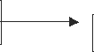
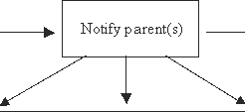
Language other than English English proficient or not eligible
Referred for language proficiency assessment
Student is not identified as EL
I
Parents meet with EL Liaison.
Parents may waive student from program.

Student is identified as EL

Entrance into sheltered English immersion program

Program placement in EL program at appropriate grade level

Annual review of progress, continuing services, exit from ESL to regular education
Parent notified by letter

Opting Out Policy For Els in
North Brookfield Public Schools

Parents are informed about their right to opt-out their child from ESL instruction at the time of enrollment. Parents/guardians may request to opt-out their child from ESL Instruction at any time. In such situations, the EL student maintains the EL designation and is still required to take the ACCESS test every year. Schools are North Brookfield Public Schools is still required to provide educational supports available at the school that would help address the academic needs of the student. The district is also required to monitor opt-out students. Parents can rescind their opt-out request at any time. A file of the student will be maintained in the office of Student Services. All students whose parents or guardians opt-out must fill out and sign the Opt-Out form.

STUDENT ASSESSMENTS

Several tests may be used for the assessment of language dominance, oral proficiency, and reading and writing skill levels. The assessment results from any of the instruments indicated below are to be used as resources and guides by the ESL team when determining entry into or exit from programs. Results of district, state, and school-based assessments are also used to provide additional information on the academic performance of the student. Procedures for current annual ELL assessments can be found in Appendix J.

Parents are sent a notification letter providing them with essential testing information prior to each test (Appendix K).

Descriptions of Current Assessments

Pre-IPT The Pre-IPT English & Spanish language assessments provide diagnostic reports on a child’s language skills– an essential component in program planning and tailoring instruction to support the development of students’ proficiency in a second language.

Pre LAS The English Language Proficiency Assessment for Early Learners: Consists of an oral language component and a pre-literacy component. May be used to assess students ages 3 to 6. Produces test results that may be used to:

      - Identify incoming students
      - Place second language learners in appropriate classroom settings
      - Monitor student progress along the stages of language acquisition
      - Report language acquisition/skills in early childhood dual language programs
      - Provides a standardized language proficiency measure for all students

Kindergarten W-APT The Kindergarten W-APT is available at no cost to WIDA Consortium and WIDA International School Consortium members.

WIDA Model Kindergarten is a flexible, on-demand English language proficiency assessment. The test can be administered at any time during the school year, depending on the needs of the district, school, teacher or student.

WIDA Screener WIDA-ACCESS Placement Test is a language ability and proficiency assessment consisting of speaking, reading, writing, and listening components.

Accessing Comprehension and Communication in English State to State (ACCESS) is an annual assessment required by the Department of Education. The ACCESS measures academic English language skills necessary for functioning in classes conducted in English.

Assessment Instruments by Grade Level

GRADE | TEST | USE | WHEN ADMINISTERED
Pre-K | Pre-IPT Oral Age 3 Pre-IPT Oral Age 4 Pre-IPT Oral Age 5 and/or  Pre LAS-  Observational Assessment Pre LAS | Identify incoming students  Place second language learners in appropriate classroom settings Monitor student progress along the stages of language acquisition Report language acquisition/skills in early childhood dual language programs  Provides a standardized language proficiency measure for all students | New students with home language other than English on HLS or teacher referral.
K | WIDA MODEL | Identify incoming students  Place second language learners in appropriate classroom settings Monitor student progress along the stages of language acquisition Report language acquisition/skills in early childhood dual language programs  Provides a standardized language proficiency measure for all students | New students with home language other than English on HLS or teacher referral.
K | Kindergarten W-APT | W-PAT is an English language proficiency screener given to incoming Kindergarteners to identify English learners (ELs). | New students with home  language other than English on HLS or teacher referral.
K-12 | WIDA Screener | English Language Proficiency  “Screener” for Listening, Speaking, Reading, & Writing. | New students with home language other than English on HLS or teacher referral.
K | Kindergarten Access for ELs | ELs (Kindergarten ACCESS) is a paper-based test individually administered to Kindergarten students in a game-like, interactive format.  Identification/Placement Progress Monitoring. | Annually
1- 12 | Access for Els Online | ACCESS Online) is a computer-based, adaptive test that responds to student performance and may be administered in group or settings. | Annually.

THE EDUCATIONAL PROGRAM

The ESL program for each school/student will be developed in partnership with the building ESL team and administration, including the Student Services director, the principal, and the superintendent and/or assistant superintendent of schools and reviewed each year to accommodate the needs of students who need services. Language proficiency levels will be determined from assessments, student work samples, and teacher recommendation from ESL staff and classroom teachers. The building ESL team will be consulted to prepare the instructional program for each student.

Depending upon the assessment results, students may receive English Language Development (ELD) lessons or direct instruction in language skills by a certified ESL teacher and/or be placed in a Sheltered English Immersion (SEI) program. Teachers in SEI classrooms have been trained according to the DESE regulations to be qualified to teach Els in their classrooms.

The SEI program provides students with books and instructional materials in English; however, the curriculum and presentation of lessons are designed for students who are learning the English language. At some point, there may be a need to use the native language when necessary for clarification. The ELL content instruction is based on the Massachusetts English Curriculum Frameworks and the 2015 WIDA standards. The WIDA standards are aligned to the Common Core Standards. (An overview of the new WIDA standards is found at: https://wida.wisc.edu/. Parents are notified of their child’s progress periodically throughout the year (Appendices M, N and O).

The ESL teacher and student services will maintain EL student folders. There is a comprehensive file in the student services in addition to the requirement of the ESL teacher. Each folder has a checklist that the teacher uses to document the collection of student data, report cards, progress reports, and parent communication (Appendix L).

ESL School-Based Student Teams

In order to make the best educational decisions regarding student services for our English language learners each school has established a team. Membership in the team may change depending upon the needs of the student(s) being discussed. The core members are the ESL teacher, the student’s classroom teacher, and a guidance or adjustment counselor. Membership may also include a Reading Specialist, an administrator, a Special Education teacher, and others as needed. In general, the team does not meet formally, and decisions are made informally through consultations and communication among the members. Teams meet to discuss an individual student’s learning and program needs, to make appropriate emotional or instructional recommendations, and to monitor a student’s language acquisition and academic progress

STUDENT SUPPORT SERVICES

District Curriculum Accommodation Plan

The district is fully committed to meeting the educational and learning needs of all students. We recognize that all our students have individual learning styles that at one time or another may require some kind of accommodation within the classroom or school environment. Consequently, in each of our schools, we have a variety of supports available to all students who may need them. Students and their teachers are encouraged to explore and avail themselves of district-wide services and programs that address diverse learning needs.

Special Education Referrals

ELs may be considered for special education when there is a concern regarding academic progress and/or social emotional needs. However, the lack of English language proficiency is not a basis for finding a student either eligible or ineligible for special education. If a student is found eligible for special education, his/her participation in ESL continues until the student is exited for proficiency.

Equal Access to Academic and Non-Academic/Extracurricular Activities

In accordance with Title VI of the Civil Rights Act of 1964, the district prohibits discrimination, exclusion from participation, and denial of benefits based on race, color, or national origin in any programs or activities that are offered by the North Brookfield Public Schools. District personnel must make every effort to ensure that (1) ELs have access to the full range of opportunities, supports, and services that are available to any non-ELs; (2) LEP students participate fully with their English-speaking peers; and (3) LEP students are provided the necessary supports for participation in academic and non- academic/extracurricular programs and activities.

MONITORING PROGRESS OF EL STUDENTS

- Each EL is evaluated annually for English proficiency and content skills. Students in grades K–
12 will be assessed annually in English language skills using the ACCESS (Assessing Comprehension and Communication in English State-to-State). All ELs will also participate in the MCAS testing appropriate to their grade levels. These results are documented in the students file and submitted to the ESL Teacher who will document these also in the EL folder. Copies of the ACCESS and MCAS results will be provided to the parents.

- Regularly scheduled progress reports reflecting the current Massachusetts standards will be prepared for each EL by the ESL teacher (Appendices M, N and O) and submitted to the supervising ESL teacher, guidance counselors, and parents.

- Each building ESL team will meet to review the progress of all ELs in that school twice per year: after the end of the first trimester for elementary students or first semester for middle and high school students and within 30 days prior to the end of the school year or the first 30 days of the next school year to evaluate each Els progress and ensure that each student is appropriately placed and monitored. At the end of/beginning of year meeting, the school ESL Team will make written recommendations for the next/current year’s placement for Els based on placement criteria. The placement criteria are GUIDELINES (Appendix P). Verification of these meetings and the resulting recommendations will be documented in each student’s cumulative folder with a copy sent to the Director of Student Services. Parents/guardians will be notified in writing of their child’s placement as continuing EL status, reclassification as FEL, or exiting FEL status (Appendices Q, R, S and T).

- Chapter 71A and Title VI require that ELs are entitled to language support services until they are proficient enough to participate meaningfully in the district’s general education programs. Districts cannot limit the time necessary for language services for those students who are not yet able to participate meaningfully in the school’s programs.

- Monitoring Tools:
  - ACCESS – Comprehension and Communication in English
  - WIDA-ACCESS Placement Test
  - State Testing (MCAS)
  - Student Portfolios including writing samples
  - District Common Assessments
  - Reading Assessments (BAS (Benchmark Assessment System), running records, etc.)
  - Other assessments as needed by the ESL team

EXITING STUDENTS FROM EL PROGRAM

(Reclassification from EL to FEL)

Exit Procedures:

Each building ESL team will meet to review the progress of all ELs twice per year as outlined above (Monitoring Progress of ELs). The team will conduct a review of each student’s progress and determine if that student no longer requires ESL services and can be reclassified as FEL (Content Area Teacher Progress Report for Reclassification; Reclassification Guidelines, Appendices Q and R).

Exit Criteria:

ELs who meet the district exit criteria will exit the program and be reclassified as FEL. Students who do not meet the exit criteria outlined will be recommended for continuing services. Any change in the instructional program will be documented in the student’s school record. The principal or designee will inform the parents in writing as to whether the student will remain as EL or be reclassified as FEL using the reclassification requirement guidelines. A copy of this letter will be filed in the student cumulative and EL folders.

Post-Service Monitoring:

The ESL Teacher will review FEL student report cards and conduct periodic consultations with classroom teachers to ensure that the FEL student is continuing to be successful in the regular classrooms. This monitoring will continue for four years, thus adhering to the DESE regulations. If the FEL student is not meeting with success, the ESL Teacher will reconvene the EL Team to redesignate the student to ELs status and ESL services will resume. If the FEL student continues to make adequate progress for two years, an Exit from FEL to Regular Education form (Appendix T) will be placed in their cumulative and EL folders. Evidence of sustained performance will include progress reports, report cards, and standardized test scores.

APPENDIX A: North Brookfield Home Language Survey

Home Language Survey

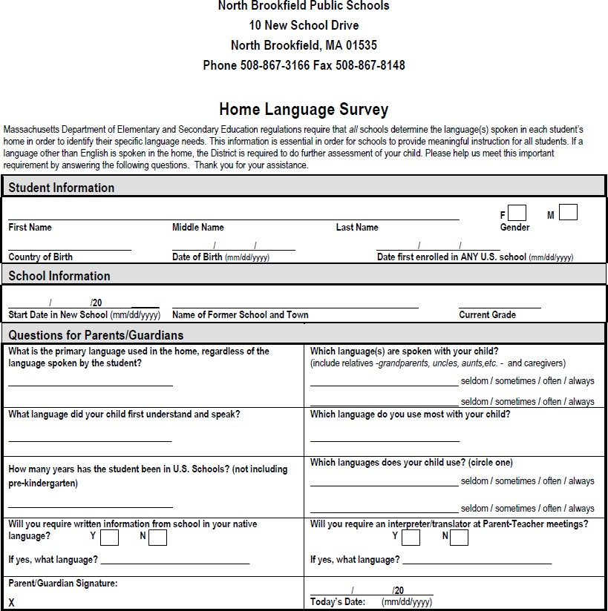

APPENDIX B: INITIAL IDENTIFICATION OF ELS IN Pre-K, KINDERGARTEN AND GRADES 1-12

TEST | Age/Pre-K | DOMAINS ASSESSED | NOT EL
Pre-IPT Oral Age 3 | FIRST Trimester Age 3 | Listening; Speaking | Score at Level C (on a scale of A-E)
Pre-IPT  Age4 | FIRST Trimester Age 4 | Listening; Speaking | Score at Level D (on a scale of A-E)
Pre-IPT  Age5 | FIRST Trimester Age 5 | Listening; Speaking | Score at Level E (on a scale of A-E)
Pre LAS Observational Assessment | Age 3-3.5 | Oral Language and Early Literacy | 60 or higher  (oral Language 45 and Early Literacy 24)
Pre LAS Observational Assessment | Age 3.6-3.11 | Oral Language and Early Literacy | 69 or higher  (oral Language 45 and Early Literacy 24)
Pre LAS | Age 3-5 | Listening; Speaking | Total Score higher than 77 (3-4 years old)  Total Score higher than 82 (5-6 years old)

TEST | KINDERGARTEN | DOMAINS ASSESSED | NOT EL
W-APT Kindergarten | FIRST Semester | Listening; Speaking | Oral Proficiency  Raw Score 29 or higher
W-APT Kindergarten | SECOND Semester | Listening; Speaking; Reading; Writing | Oral Proficiency raw Score 29 or higher Reading - raw score 14 or higher Writing - raw score 17 or higher
WIDA Model Kindergarten | FIRST Semester | Listening; Speaking | Oral Proficiency  Level 5 in both Listening and Speaking
WIDA Model Kindergarten | SECOND Semester | Listening; Speaking; Reading; Writing | Overall Composite Proficiency  Level higher than 5 and Composite Level higher than 4

TEST | Grades 1-12 | DOMAINS ASSESED | NOT EL
WIDA Screener |  | All Four | Overall Composite Proficiency Level 4.5 or higher and  Composite Literacy Proficiency Level 4.5 or higher

APPENDIX C: PARENT NOTIFICATION OF IDENTIFICATION FOR EL SERVICES
North Brookfield Public Schools School Year 2021-2022
Parental Notification Regarding English Language Education

Dear Parent(s)/Guardian(s):

In order to comply with state requirements, school districts must inform parents of students whose home language is other than English of the rights they may have regarding English language education (ELE). The district will test your child in English reading, writing, speaking, and listening to determine if your child is an English learner. If your child is found to be an English learner and eligible for placement in an ELE program, you will receive further notification with your child’s English proficiency test results and program placement information.

If your child is determined to be an English learner, you have the right to:
- choose an ELE program among those offered by the district as described in state law and regulations.
- visit an ELE program in the district.
- attend available conferences or meetings to learn more about the ELE programs offered in the district.
- request a new ELE program in accordance with state law; and
- withdraw your child from an ELE program.

Available ELE programs include (check all that apply):
- Sheltered English Immersion (SEI) – an ELE program in which sheltered grade-level content instruction is used. Sheltered content instruction is content instruction that is modified so that an English learner can comprehend it and participate in the class at his or her level of English proficiency. All instruction and materials are in English.
- Dual Language Education or Two-Way Immersion (TWI) – an ELE program that develops students’ language skills in two languages (English and another language). This program includes native English-speaking students and students who are native speakers of another language.
- Transitional Bilingual (TBE) – an ELE program in which the English learner’s native language is used to support the student’s development of English and content learning and is then gradually phased out of instruction as the student’s English proficiency increases.
- Other Bilingual – other bilingual instructional program for English learners (not Two-Way Immersion or Transitional Bilingual Education).

All ELE programs include English as a Second Language (ESL) instruction. ESL classes provide direct English language instruction that focuses on developing speaking, listening, reading, and writing skills in English.

Districts serving 100 or more English learners or in which English learners comprise at least 5% of the student population, whichever is less, are required to establish an English learner parent advisory council (ELPAC). Similarly, any school designated as underperforming or chronically underperforming and operating an ELE program is required to establish an ELPAC. Parents of -English learners are encouraged to participate in such councils.
-
For more information about the topics discussed in this notice, please contact: Anna Robert at 508-867-3166 or anrobert@nbschools.org.

APPENDIX D: PARENT NOTIFICATION OF IDENTIFICATION FOR CONTINUATION OF EL SERVICES
PARENT NOTIFICATION OF IDENTIFICATION FOR CONTINUATION OF EL SERVICES
North Brookfield Public Schools English Learners Program

Date Grade

Student’s name School

This letter informs you that ESL services continue for your child. To ensure the academic success of all students, the Massachusetts Department of Elementary and Secondary of Education requires that students whose home language is a language other than English participate in English language proficiency assessments. Based on the results of the Winter ACCESS assessment, other EL and classroom assessments, it is recommended that your child continue to receive EL support. He/she has not yet reached the recommended level of English language proficiency in the four language domains of reading, writing, listening and speaking.

Our goal is to provide your child with more individualized attention to improve his/her speaking, listening, and reading and writing readiness skills in English while supporting the regular classroom curriculum when possible. Your child will receive English language instruction in his/her classroom from his/her teacher. Your child will also receive additional ESL instruction both in and out of the classroom, as determined by the ESL team.

During the year, and based on your child’s needs, he/she will be assessed for English language proficiency and then either recommended for continuation of EL services or exited from the program.

You can decline EL support. However, when services are declined, students continue to participate in the required state assessment, ACCESS. Should you choose to decline, you must first contact your ESL teacher; the contact information can be found below. If you prefer that your child receive a different type of language support, you may apply for a Waiver; please see the attached General Laws Chapter 71A Program Waiver and General Laws Chapter 71A Waiver Application Form.

If you should have any further questions, please feel free to contact Samantha Josti at 508-867-8326 ext.2114, or via email sjosti@nbschools.org.
Thank you,

Samantha Josti

APPENDIX E: ENGLISH LANGUAGE LEARNER SERVICES DECLINED

ENGLISH LEARNER SERVICES Opt-Out
Letter

North Brookfield Public Schools

School Year 2021-2022
OPT-OUT FORM

Student Name: | Home language:
Opt-out Date: | Years in U.S. Schools:
SASID: | DOB:
School: | Grade:

As required by federal law, my child has taken an English language proficiency test (W-APT, WIDA ACCESS, or WIDA MODEL). My child has been tested in reading, writing, speaking and listening and the test scores indicate that s/he is eligible for an English Learner Education (ELE) program to receive ESL instruction in a program designed to help students acquire English language proficiency and access grade level content instruction. I have considered the options offered by the district and have chosen to decline ELE services. I understand that my decision to opt-out of ELE services will not affect the requirements the district needs to follow in order to comply with the state and federal laws. I understand that:

- As per this request, my child will not receive specialized ESL instruction delivered by an ESL licensed teacher.
- My refusal of ELE services does not release the district from its obligation to ensure that my child has access to the educational program by providing the necessary support in SEI classes taught by an SEI endorsed teacher.
- The school district will report my child to Student Management Information System (SIMS) as an English Learner (EL) until my child attains English proficiency.
- As long as my child is enrolled in Massachusetts public schools, s/he will be tested annually with ACCESS until s/he attains English proficiency.
- As long as my child is enrolled in Massachusetts public schools, the school district will monitor my child’s academic progress without benefit of receiving specialized ESL instruction until my child attains English proficiency, and four years after.
- The school district will continue to inform me of my child’s progress in attaining English proficiency.
- I can change my preference at any time by notifying the school district in writing.

Parent/Guardian Signature: Date:

APPENDIX F: PROCEDURES FOR ANNUAL EL ASSESSMENTS

  - The ESL teacher(s) at each school will provide the principal with a list of students and the annual assessments that each student is required to take (ACCESS) to the Director of Student Services.

  - Principals are responsible to notify the MA DESE of the number of tests that are needed in each school

  - The Student Services Director and/or Designee will send a notification letter to the parents informing them of the name and dates of the test administration.

  - The principal, in coordination with the Director of Student Services will determine the time and location of testing.

  - The Director of Student Services and/or Designee will send letters to the classroom teachers notifying them of the time and place of the ACCESS tests.

  - The principal will return the tests to the DESE for scoring.

  - The principal will place the original test results in the student file (Student Services) and provide a copy to the ESL teacher.

  - The ESL teacher will verify that the results are in the student file during the next semi-annual file check (January and June).

APPENDIX G: ACCESS LETTER TO PARENTS
NORTH BROOKFIELD PUBLIC SCHOOLS
North Brookfield Public Schools strives to assist every English learner (EL) in attaining English proficiency.¹ The district monitors the progress that ELs are making in meeting English proficiency benchmarks. For ELs who are not meeting English proficiency benchmarks, the district will:
    - Identify areas in which the EL needs improvement;
    - Establish personalized goals for the EL to attain English proficiency;
    - Assess and track the progress of the EL in the identified areas in need of improvement;
    - Obtain and incorporate input from the parents or legal guardian of the EL; and
    - Review resources and services available to assist the EL.

In reviewing resources and services to assist ELs, our district may take the following steps:
    - Evaluate strategies for improving instructional practices and routines for ELs;
    - Provide additional support to teachers of ELs, including professional development and coaching;
    - Examine the adequacy of the curriculum and materials available to teachers of ELs;
    - Obtain supplemental materials designed to assist ELs who are struggling with attaining English proficiency;
    - Establish language support teams that may include English as a second language (ESL) teachers, content teachers, school administrators, guidance counselors, and other relevant personnel.
    - Support structured collaborative opportunities for teachers of ELs (ESL teachers and content teachers) to review student performance data regularly.
    - Review resources provided by the Department of Elementary and Secondary Education at http://www.doe.mass.edu/ele/

In addition to the specific steps above, our district may also consider the following:
    - Successful approaches taken by schools to assist ELs and ways to adopt them;
    - Development or improvement of the plan for addressing the instructional and social emotional learning needs of ELs;
    - Implementation or continued implementation of English Learner Parent Advisory Councils;
    - Examination of opportunities for increased family engagement, including taking additional steps to create an inclusive environment.
Our district also has available the following resources to assist ELs
Qualified ESL instructor and instruction, Title 1 and reading specialist, Chromebook assigned to student, Class Dojo for student and parent communication in the native language, qualified SEI endorsed teachers, an after school program for further language development, and supplemental English Learning resources.

If you have questions regarding your child’s testing, call the school district to speak to Anna Robert, Director of Student Services at (508) 867-3166

Anna Robert
Director of Student Services North Brookfield Public Schools 10 New School Drive
North Brookfield, MA 01535

¹ English learner is a student who does not speak English or whose native language is not English, and who is not currently able to perform ordinary classroom work in English.

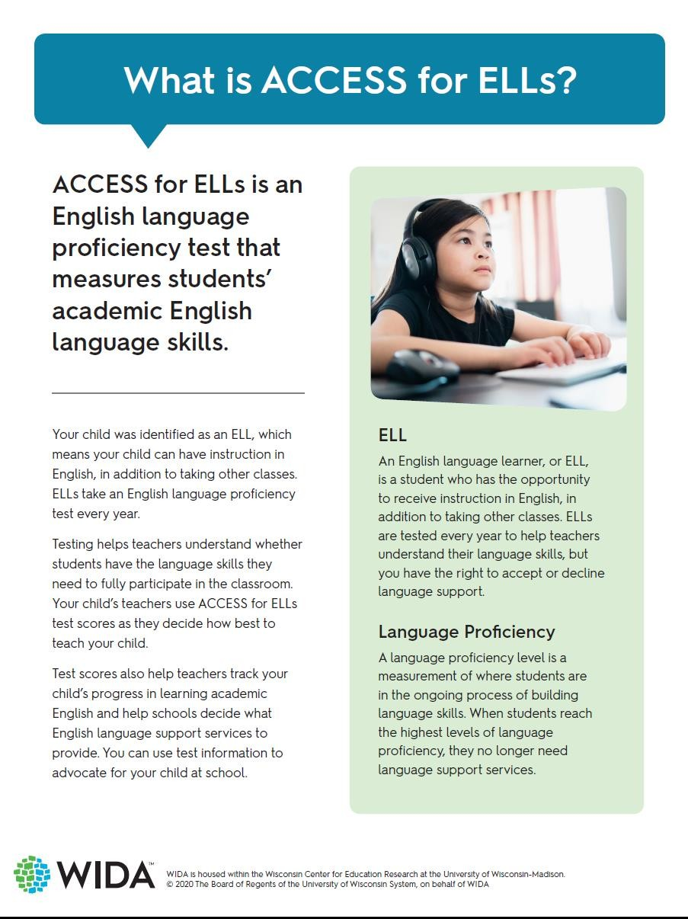

North Brookfield Public Schools 2020 - 2021 School Year Page 29

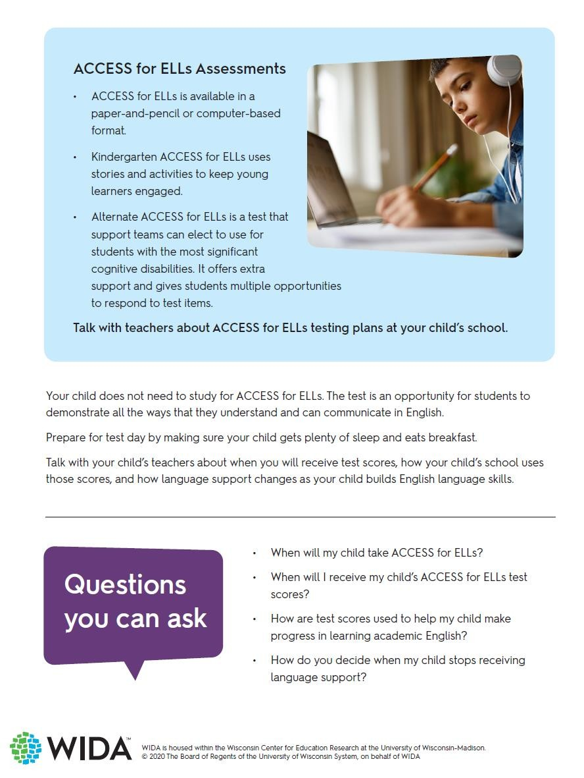

North Brookfield Public Schools 2020 - 2021 School Year Page 30

APPENDIX H: FOLDER CHECKLIST

Student Name: SASID #
Date of birth: Date of Entry into Program:

School Year | 2021-2022 | 2022-2023 | 2023-2024 | 2024-2025 | 5  2025-2026
Initials/Teacher
El/FEL
ELP Level
Grade
Schedule
HLS
Parent Notification
Decline Letter (if applicable)
W-APT Results
ACCESS results
MODEL Results
ESL Progress Reports - Winter
ESL Progress Reports - Spring
Content Teacher Progress Reports (include entire year of grades)
FEL Monitoring Form
MCAS Results

APPENDIX I: MID-YEAR PROGRESS REPORT

MID-YEAR PROGRESS REPORT INSERT SCHOOL YEAR
English Learner Program

Student Name: Date:

School: Grade:

ESL Teacher:

WIDA
Consortium
English Language Proficiency Levels

Proficiency Level | Description of English Language Proficiency Levels
1- Entering | Knows and uses minimal social language and minimal academic language with visual support
2 – Emerging | Knows and uses some social English and general academic language with visual support
3 – Developing | Knows and uses social English and some specific academic language with visual support
4 – Expanding | Knows and uses social English and some technical academic language
5 – Bridging | Knows and uses social and academic language working with grade level material
6 – Reaching | Knows and uses social and academic language at the highest level measured by this test

Comments: Target (content/language objective) of recent project/skill work; progress in performance domain(s) of greatest focus since September; suggestion(s) future support:

APPENDIX J: MONITORING ACADEMIC PROGRESS OF OPT-OUT STUDENTS GRADES 6-12

North Brookfield Public Schools
School Year 2020-2021
MONITORING ACADEMIC PROGRESS OF OPT-OUT STUDENTS

Federal law establishes a district’s obligation to provide ELs with meaningful access to the educational program. When a parent declines participation in a formal language instruction program, the district must continue monitoring the educational progress of the student to ensure that the student has an equal opportunity to have his or her English language and academic needs met.

Student Name: Opt-out Date: SASID:
School:
Home language: Years in U.S. Schools: DOB:
Grade:

ATTENDANCE / TARDY DATA
 | Term 1 | Term 2 | Term 3 | Term 4
Attendance
Tardy

E N G L I S H | Test Scores  MCAS: |  | ACCESS: |  | OTHER:
E N G L I S H |  | Term 1• | Term 2• |  | Term 3 • |  | Term 4•
E N G L I S H |  |  |  | RARELY | SELDOM | SOMETI MES | OFTEN | ALWAYS
E N G L I S H | Communicates effectively in English
E N G L I S H | Completes homework
E N G L I S H | Participates in class
E N G L I S H | Discipline issues that interfere with his or her progress
E N G L I S H | Struggles with oral expression
E N G L I S H | Struggles with written expression
E N G L I S H | Struggles with oral comprehension
E N G L I S H | Struggles with reading comprehension

M A T H | Test Scores  MCAS: |  | OTHER:
M A T H |  | Term 1• | Term 2• |  |  | Term 3 • |  | Term 4•
M A T H |  |  |  | RARELY | SELDOM |  | SOMETI MES | OFTEN | ALWAYS
M A T H | Communicates effectively in English
M A T H | Completes homework
M A T H | Participates in class
M A T H | Discipline issues that interfere with his or her progress
M A T H | Struggles with oral expression
M A T H | Struggles with written expression
M A T H | Struggles with oral comprehension
M A T H | Struggles with reading comprehension

S C I E N C E | Test Scores  MCAS: |  | OTHER:
S C I E N C E |  | Term 1• | Term 2• |  |  | Term 3 • |  | Term 4•
S C I E N C E |  |  |  | RARELY | SELDOM |  | SOMETI MES | OFTEN | ALWAYS
S C I E N C E | Communicates effectively in English
S C I E N C E | Completes homework
S C I E N C E | Participates in class
S C I E N C E | Discipline issues that interfere with his or her progress
S C I E N C E | Struggles with oral expression
S C I E N C E | Struggles with written expression
S C I E N C E | Struggles with oral comprehension
S C I E N C E | Struggles with reading comprehension

S O C I A L  S T U D I E S | Test Scores  MCAS: |  | OTHER:
S O C I A L  S T U D I E S |  | Term 1• | Term 2• |  |  | Term 3 • |  | Term 4•
S O C I A L  S T U D I E S |  |  |  | RARELY | SELDOM |  | SOMETI MES | OFTEN | ALWAYS
S O C I A L  S T U D I E S | Communicates effectively in English
S O C I A L  S T U D I E S | Completes homework
S O C I A L  S T U D I E S | Participates in class
S O C I A L  S T U D I E S | Discipline issues that interfere with his or her progress
S O C I A L  S T U D I E S | Struggles with oral expression
S O C I A L  S T U D I E S | Struggles with written expression
S O C I A L  S T U D I E S | Struggles with oral comprehension
S O C I A L  S T U D I E S | Struggles with reading comprehension

Please, check the one that applies:

At a meeting on (date) the Language Acquisition Team reviewed the student’s performance and concluded that he/she meets grade level academic standards.
  - At a meeting on (date) the Language Acquisition Team reviewed the student’s performance and concluded that language proficiency IS NOT a significant reason the student is not meeting grade level academic standards. Student was/ will be referred to Student Support Team on (date)

  - At a meeting on (date) the Language Acquisition Team reviewed the student’s performance and concluded that language proficiency IS a significant barrier preventing the student from meeting grade level academic standards.

Action Steps (check all that apply)

English language support
    - After school tutoring
    - Core academic tutoring
    - Parent communication
    - Summer school
    - Other (Please, explain)

Date:

Team members:

Signatures:

APPENDIX K: EL RECLASSIFICATION GUIDELINES

North Brookfield Public Schools

North Brookfield Public Schools may classify an EL as a Former English Learner (FEL) if the following criteria have been met:

ACCESS for ELs® Overall (or Composite) Score |  | Language Classification Recommendations
Level 1 – Entering Level 2 – Emerging Level 3 – Developing | Students performing at Levels 1–3 in all or some language domains as measured by the ACCESS for ELs® require significant support to access content area instruction delivered in English. Such students should remain classified as ELs.
Level 4 –  Expanding | Students performing at Level 4 in all or some language domains as measured by the ACCESS for ELs® typically require continued language and instructional support to access content area instruction delivered in English. Student at this proficiency level must still remain in the program and be provided services to reach higher levels of English proficiency.
Level 5 –  Bridging | Students performing at Level 5 in all language domains as measured by ACCESS for ELLs® may have acquired enough English language skills to be considered English proficient. These students who demonstrate the ability to perform ordinary class work in English as indicated by one or more of the measures listed on Other Relevant Data (described below) should no longer be classified as ELs.  Complex and varied language demands on ELs in late elementary, middle, and high school may necessitate the decision to maintain the EL classification of a student who scores at or above level 5 in all language domains. Should the student remain in the program, s/he must still be provided services appropriate for his/her English proficiency in each domain.
Level 6 –  Reaching | By the time a student reaches Level 5.5 or greater in both reading and writing and Level 6.0 in speaking and listening, he or she should no longer be classified as EL. Students who achieve these levels of proficiency as measured by the ACCESS for ELs® can reasonably be considered to have achieved English language proficiency comparable to that of their English- proficient peers and can be expected to perform ordinary class work in English without specialized language supports.
*MA Guidance on Identification, Assessment, Placement and Reclassification of English Language Learners (24-25)

ADDITIONAL DATA

In addition to ACCESS scores, the following criteria will be considered when assessing a student’s reclassification:

- GRADE assessment score (For Grades 3-8)
  - An EL exiting ESL services should have no more than a 3-stanine differential among subtests. A discrepancy in subtests indicates the potential for growth. Support may need to come from an ESL classroom or an alternate intervention service to be determined by the ESL teacher.

- A written recommendation to reclassify the student from 2 of the student’s content area teachers in the form of an EL Student Report
  - Work samples justifying the teachers’ recommendation

- MCAS ELA score of Proficient

- An evaluation from the ESL teacher and program director stating that the student meets the Level 5 or Level 6 EL standards from the Massachusetts Department of Elementary and Second Education (Appendix P).

APPENDIX L: GRADES 1 – 5 FEL MONITORING FORM

North Brookfield Public Schools
Monitoring of Former English Learners (FEL) Grades 1-5

Student Information
Name of student Grade:

The district is required to report former LEP students’ progress for two years after program exit:

Year two Date of report 1 Date of report 2
(Winter) (Spring)
Current Academic and Other Support Services

Name of classroom teacher Year Two

Is the child progressing satisfactorily in your classroom? Yes No
If “no” please comment briefly on key areas of concern. (You will be contacted by an ESL teacher). Winter Year 2:

Spring Year 2:

Check if any support services are being received. If so, circle the service(s). Year Two:
Title I Math Reading
Other:

Please return this form to the ESL teacher in your school.
This form will be filed in the student’s cum folder.
Thank you.

North Brookfield Public Schools
APPENDIX M: MONITORING ACADEMIC PROGRESS OF FEL STUDENTS GRADES 6-12

School Year 2021-2022
MONITORING ACADEMIC PROGRESS OF OPT-OUT STUDENTS

Federal law establishes a district’s obligation to provide ELs with meaningful access to the educational program. When a parent declines participation in a formal language instruction program, the district must continue monitoring the educational progress of the student to ensure that the student has an equal opportunity to have his or her English language and academic needs met.

Student Name: Opt-out Date: SASID:
School:
Home language: Years in U.S. Schools:
DOB:
Grade:

ATTENDANCE / TARDY DATA
 | Term 1 | Term 2 | Term 3 | Term 4
Attendance
Tardy

E N G L I S H | Test Scores  MCAS: |  | ACCESS: |  | OTHER:
E N G L I S H |  | Term 1• | Term 2• |  | Term 3 • |  | Term 4•
E N G L I S H |  |  |  | RARELY | SELDOM | SOMETI MES | OFTEN | ALWAYS
E N G L I S H | Communicates effectively in English
E N G L I S H | Completes homework
E N G L I S H | Participates in class
E N G L I S H | Discipline issues that interfere with his or her progress
E N G L I S H | Struggles with oral expression
E N G L I S H | Struggles with written expression
E N G L I S H | Struggles with oral comprehension
E N G L I S H | Struggles with reading comprehension

M A T H | Test Scores  MCAS: |  | OTHER:
M A T H |  | Term 1• | Term 2• |  |  | Term 3 • |  | Term 4•
M A T H |  |  |  | RARELY | SELDOM |  | SOMETI MES | OFTEN | ALWAYS
M A T H | Communicates effectively in English
M A T H | Completes homework
M A T H | Participates in class
M A T H | Discipline issues that interfere with his or her progress
M A T H | Struggles with oral expression
M A T H | Struggles with written expression
M A T H | Struggles with oral comprehension
M A T H | Struggles with reading comprehension

S C I E N C E | Test Scores  MCAS: |  | OTHER:
S C I E N C E |  | Term 1• | Term 2• |  |  | Term 3 • |  | Term 4•
S C I E N C E |  |  |  | RARELY | SELDOM |  | SOMETI MES | OFTEN | ALWAYS
S C I E N C E | Communicates effectively in English
S C I E N C E | Completes homework
S C I E N C E | Participates in class
S C I E N C E | Discipline issues that interfere with his or her progress
S C I E N C E | Struggles with oral expression
S C I E N C E | Struggles with written expression
S C I E N C E | Struggles with oral comprehension
S C I E N C E | Struggles with reading comprehension

S O C I A L  S T U D I E S | Test Scores  MCAS: |  | OTHER:
S O C I A L  S T U D I E S |  | Term 1• | Term 2• |  |  | Term 3 • |  | Term 4•
S O C I A L  S T U D I E S |  |  |  | RARELY | SELDOM |  | SOMETI MES | OFTEN | ALWAYS
S O C I A L  S T U D I E S | Communicates effectively in English
S O C I A L  S T U D I E S | Completes homework
S O C I A L  S T U D I E S | Participates in class
S O C I A L  S T U D I E S | Discipline issues that interfere with his or her progress
S O C I A L  S T U D I E S | Struggles with oral expression
S O C I A L  S T U D I E S | Struggles with written expression
S O C I A L  S T U D I E S | Struggles with oral comprehension
S O C I A L  S T U D I E S | Struggles with reading comprehension

Please, check the one that applies:
- At a meeting on (date) the Language Acquisition Team reviewed the student’s performance and

concluded that he/she meets grade level academic standards.
- At a meeting on (date) the Language Acquisition Team reviewed the student’s performance and

concluded that language proficiency IS NOT a significant reason the student is not meeting grade level academic standards. Student was/ will be referred to Student Support Team on (date) .
- At a meeting on (date) the Language Acquisition Team reviewed the student’s performance and

concluded that language proficiency IS a significant barrier preventing the student from meeting grade level academic standards.

Action Steps (check all that apply)

English language support
  - After school tutoring
  - Core academic tutoring
  - Parent communication
  - Summer school
  - Other (Please, explain)

Date:

Team members: Signatures:

APPENDIX N: FEL Reclassification NOTIFICATION TO PARENTS/GUARDIANS K-12

North Brookfield Public Schools School Year 2021-2022
English Language Education Program Reclassification Form

Name: | SASID# | Date of Birth:
School: | Grade: | Reclassification Date:

Students should earn at least an overall score of 4.2 and a composite score of 3.9 on ACCESS for ELs 2.0 in order to be considered as Former English Learner (FEL).

RECLASSIFICATION CRITERIA
Additional Requirements | Meets Criteria | Does Not Meet Criteria
Earned at least an overall score of 4.2 and a composite literacy score of 3.9 on ACCESS for ELs 2.0 |  | Students who do not have an overall score of 4.2 and a composite literacy score of 3.9 cannot be considered for reclassification based on the  other relevant data.
Demonstrate the ability to perform ordinary class work in English, as indicated by more than one of the measures listed on Other Relevant Data (described below)

Data used:
Comments:

APPENDIX O: EXIT FROM FEL STATUS

North Brookfield Public Schools
Parent Notification of Exit from FEL Status
Student’s Name: Grade: Date: School:

Dear Parents:

I would like to inform you that, based on your student’s classroom performance and his/her scores on state and local assessments, a team of teachers in your student’s school has determined that he/she has developed proficiency in the English language. He/she is now fully capable of performing ordinary class work in English in a mainstream classroom.

Over the past two years your student’s ESL teacher has monitored your student for . He/she no longer requires this monitoring.

If you have any questions regarding your student’s instructional needs or placement, please feel free to contact your ESL Teacher at INSERT NUMBER.

Sincerely,

